1. **Create classLibrary named Name.Services**
2. **Create data and service classes in it.**

Data class:

namespace MessageSystem.Services

{

using System;

using System.Runtime.Serialization;

[DataContract]

public class Message

{

[DataMember]

public string Text { get; set; }

[DataMember]

public DateTime DateSend { get; set; }

}

}

Service class:

using System.Collections.Generic;

using System.ServiceModel;

using System.ServiceModel.Web; // Needed for [WebGet]

[ServiceContract]

public interface IMessageService

{

[OperationContract]

[WebGet(UriTemplate="message/all")]

ICollection<Message> Get();

[OperationContract]

[WebInvoke(Method = "Post")]

void Add(Message message);

}

namespace MessageSystem.Services

{

using System;

using System.Collections.Generic;

public class MessageService : IMessageService

{

public ICollection<Message> Get()

{

return new List<Message>()

{

new Message{Text = "Some text one", DateSend = DateTime.Now},

new Message{Text = "Some text two", DateSend = DateTime.Now},

new Message{Text = "Some text three", DateSend = DateTime.Now}

};

}

public void Add(Message message)

{

throw new NotImplementedException();

}

}

}

1. **Добавя се 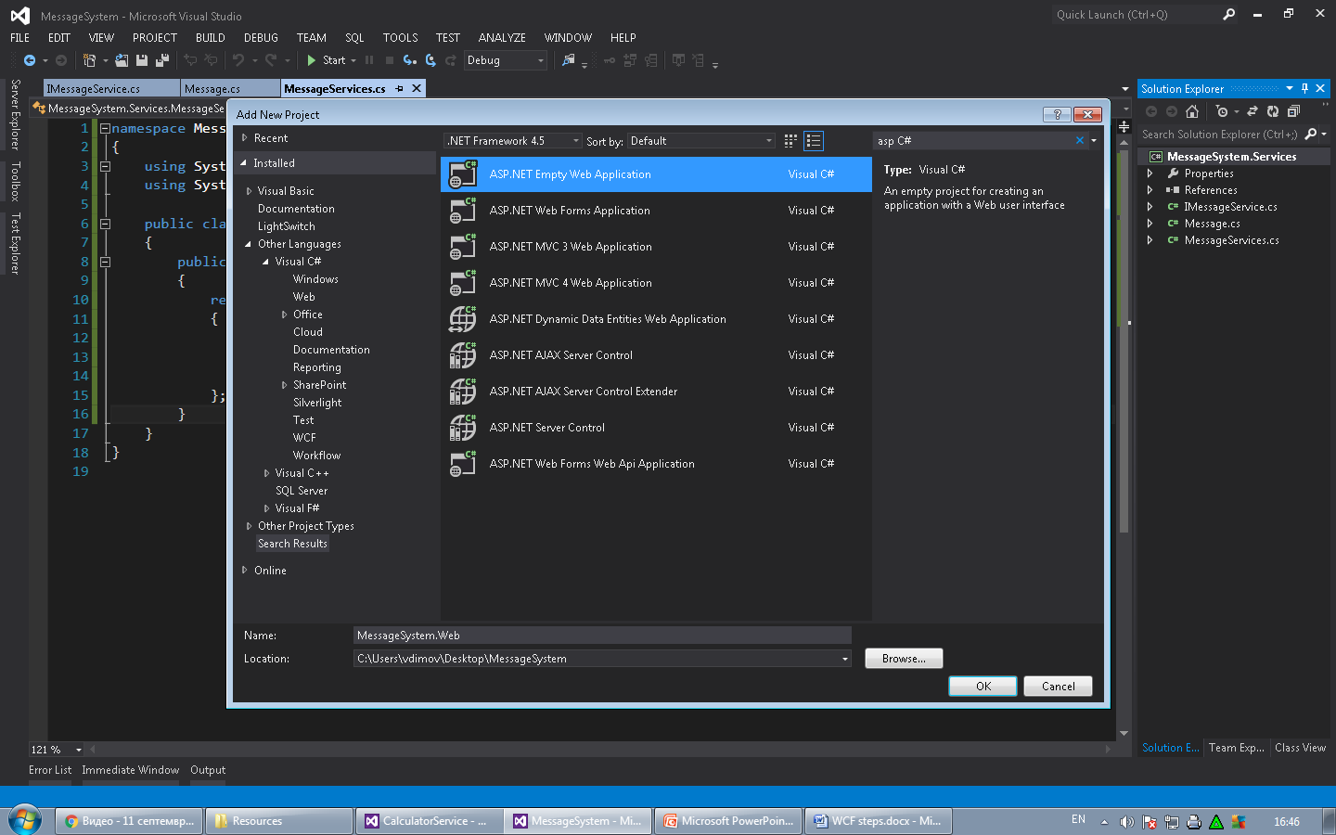. (Name.Web)**
2. **Реферира се service library.**
3. **Добавя се файл MessageService.svc**

Вътре се поставя следния код:

<%@ ServiceHost

    Language="C#"

    Debug="true"

    Service="MessageSystem.Services.MessageService"

    Factory="System.ServiceModel.Activation.WebServiceHostFactory" %>

1. **Добавя се сървиса в Web.config.**

Това не трябва за REST

<service name="MessageSystem.Services.MessageServices">

<endpoint address=""

binding="basicHttpBinding"

contract="MessageSystem.Web.IMessageService"/>

</service>

Това не трябва за REST

<serviceBehaviors>

<behavior name="">

<serviceMetadata httpGetEnabled="true" httpsGetEnabled="true" />

<serviceDebug includeExceptionDetailInFaults="false" />

</behavior>

</serviceBehaviors>

<system.serviceModel>

<standardEndpoints>

<webHttpEndpoint>

<standardEndpoint defaultOutgoingResponseFormat="Json" helpEnabled="true" />

</webHttpEndpoint>

</standardEndpoints>

</system.serviceModel>

1. **Web.Config**

<?xml version="1.0"?>

<!--

For more information on how to configure your ASP.NET application, please visit

http://go.microsoft.com/fwlink/?LinkId=169433

-->

<configuration>

<system.web>

<compilation debug="true" targetFramework="4.5" />

<httpRuntime targetFramework="4.5" />

</system.web>

<system.serviceModel>

<!--<behaviors>

<serviceBehaviors>

<behavior name="">

<serviceMetadata httpGetEnabled="true" httpsGetEnabled="true" />

<serviceDebug includeExceptionDetailInFaults="false" />

</behavior>

</serviceBehaviors>

</behaviors>-->

<serviceHostingEnvironment aspNetCompatibilityEnabled="true"

multipleSiteBindingsEnabled="true" />

<!--<services>

<service name="MessageSystem.Services.MessageService">

<endpoint address="" binding="basicHttpBinding" contract="MessageSystem.Services.IMessageService" />

</service>

</services>-->

<standardEndpoints>

<webHttpEndpoint>

<standardEndpoint defaultOutgoingResponseFormat="Json" helpEnabled="true" />

</webHttpEndpoint>

</standardEndpoints>

</system.serviceModel>

</configuration>

1. **Някои важни примери.**

* **Указване на раута и респонс формата:**

[WebGet(UriTemplate = "message/all", ResponseFormat = WebMessageFormat.Xml)]

* **Указване на метода (Get, Post, …)**

[WebInvoke(Method = "Post")]

* **Poведение при извикване на метода**

[ServiceBehavior(InstanceContextMode = InstanceContextMode.PerCall)]